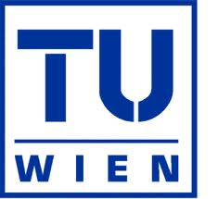


Distributed Generation in Austria and Czech
Republic

Sebastian Mosshammer
Oxana Demina

Co-operating Universities
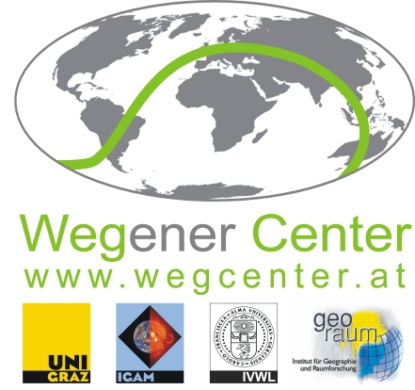


Financial support by

Prague and Vienna, 2014
CONTENT

1. ABSTRACT 3
2. INTRODUCTION 3
3. PROBLEM STATEMENT 4
3.1 What is the DG 4
3.2 Main benefits 5
3.3 Main issues 6
4. Current situation in CR and Austria 7
4.1 Austria 7
4.2 Czech Republic 12
6. CONCLUSIONS 17
7. REFERENCES 18

Research question:

What are the benefits and challenges for the development of DG in Czech Republic and Austria?
How is the present situation and the Roadmap (development plans) for the future?

1. ABSTRACT
Distributed generation (DG) is an important global current tendency in the power sector. This article analyses the main benefits and drawbacks of distributed generation compared to the ordinary, centralized way of power supply and generation by means of high-voltage power transmission systems. The main technical and economic barriers influencing the development of DG have been evaluated. This article focusses on the situation nowadays and future developing tendencies of DG in Austria and Czech Republic in the light of a worldwide tendency. Technical solutions to the problem of development the DG and government support mechanisms of DG have been proposed. The potential scenario of development for these measures has been forecasted. The analysis is based on collection and analysis of the existing empirical data and literature overview.

2. INTRODUCTION
Historically the power systems have been developing from small- to large-scale, composing large high voltage power grids. It provided economics of scale, better regulation for operators, less loss for (long) transport distances of electricity and other benefits.
However, the increasing consumption of energy worldwide, especially electricity, based mainly on the use of fossil energy, can cause problems such as overload of power grids, or even lead to blackouts and has for sure a massive environmental impact. These problems are even more actual for EU countries, since these countries consume in four times more energy per capita than Asian or Southern American countries - and as we all know, the consumption of energy is highly linked to welfare and a stable economy. The assumed main benefit behind DG is a lower impact on environment, a higher supply security and less losses of power due to the short distances of transport because the power is produced and consumed locally. Another issue, in a global point of view, is the (self-) supply of sparsely populated or far off areas, which is in most cases not economically approved by building and maintaining new power lines and connect those areas with the existing power grid.
The European Union wants to target the so called 20/20/20 aims. Which means 20% CO2-emissions reduction compared to 1990 levels, 20% improvement in the energy efficiency and to raise the consumption of energy produced from renewable resources to a share of 20%. "The European Energy Policy promotes renewable energy sources and energy efﬁciency as means to mitigate environmental impact, increase security of supply and ensure economic competitiveness. As a result, the penetration levels of distributed generation in electricity networks are bound to increase" (Rafael Cossent et al., 2008).
But there are several construction challenges that have to be met, such as technical, economic or legal barriers and the lack of government support.
Nevertheless, due to the reasons mentioned above, one of the modern tendencies in power generation nowadays, is the shift from the centralized to the distributed (grid-connected or decentralized) power generation.
In this paper we would like to figure out the influencing factors, the benefits and challenges for developing DG, especially in Austria and Czech Republic.

3. PROBLEM STATEMENT

3.1 What is the DG

The term distributed generation refers to the production of electricity near the consumption place. The power plant in this case can serve a customer on-site or providing support to a distribution network, connected to the grid at distribution or transmission voltage levels (L.I. Dulaua, M. Abrudeanb, D. Bica - Distributed generation technologies and optimization, 2013).
The installed capacity of distributed generation systems is usually less than 50 or 100 MW.
DG can differ by grid-connection: it can be decentralized or grid-connected. The simplest case of implementation distributed energy is the installation of a small, stand-alone electricity generator to provide main or backup power at an electricity consumer's site. Or it can be a more complex system, highly integrated with the electricity grid and consisting of electricity and thermal generation, energy storage, and energy management systems. In most countries distributed generation is connected to the central power grid through the distribution network. However, some countries also consider the possibility of DG connected to the transmission network. The most of DG connection is to the distribution network, but some countries, such as France and Czech Republic, consider the possibility of DG connected to the transmission network. Therefore, if not stand-alone, DG is connected to a distribution level which is up to 150 kV (F. Gonzalez-Longatt, C. Fortoul, Review of the Distributed Generation Concept: Attempt of Unification, 2003). Distributed energy resources connected to the central grid can also require power electronic interfaces, communications and control devices for efficient dispatch and operation of generating units (National Renewable Energy Laboratory, web-site).
Distributed energy comprises a wide range of technologies including wind turbines, solar power, fuel cells, microturbines, reciprocating engines, load reduction technologies, and battery storage systems. Diesel- and gasoline generators are one of the most common distributed energy technologies in use today(National Renewable Energy Laboratory, web-site). However due to the significant air/noise pollution and due to the recent environmental-friendly governmental policies natural-gas- and renewable-fueled generators are becoming more and more popular nowadays.

3.2 Main benefits
The benefits of distributed generation compared to the traditional way of central electrification are listed below.
1. Useful part of national power system
“Distributed energy technologies are playing an increasingly important role in the nation's energy portfolio. They can be used to meet baseload power, peaking power, backup power, remote power, power quality, as well as cooling and heating needs. Distributed energy also has the potential to mitigate congestion in transmission lines, reduce the impact of electricity price fluctuations, strengthen energy security, and provide greater stability to the electricity grid” (National Renewable Energy Laboratory, web-site).
2. Stand-alone(decentralized) applications
Also called Remote Access Power Systems (RAPS), which provide electricity to people that are not connected to any grid. Usually Solar-Cells or Wind-turbines combined with a battery or fuel-cell for storage or small engines powered by diesel or biogas are used to generate and provide electricity. On a stand-alone electricity basis, DG is also used as back-up power for reliability purposes.
3. Small sizing
Distributed power generators are small compared with typical central-station power plants and provide unique benefits that are not available from centralized electricity generation. One of these benefits is that generating units are inherently modular, which makes distributed power highly flexible: can provide power where it is needed and when it is needed. Another benefit is that these generating units are usually less noisy and less pollutant so that they can be installed in almost any location without the need of placing them out of inhabited area.
4. Possibility of cogeneration or heat energy generation
The use of combined cooling, heating, and power (CHP) applications lead to improved efficiency and lower energy costs. CHP systems provide electricity along with hot water, heat for industrial processes, space heating and cooling, refrigeration, and humidity control to improve indoor air quality and comfort.
5. Decreasing of power losses
In DG systems electricity is produced and consumed locally. Hence, there are less transport distances of electricity and so there are less power losses. This fact has its not only economical but also environmental benefit. Like Balamurugan et al., 2011, mentioned: "Reducing distribution network losses alone can contribute to 1% of total greenhouse gas emissions" on a global level.
6. Unloading of central grid
Grid-connected distributed energy resources also support and strengthen the central power system which includes electricity generation, transmission, and distribution. While the central generating plant continues to provide most of the power to the grid, the distributed resources can be used to meet the peak demands of local distribution feeder lines or major customers. The large grids can be hence unloaded which provides better stability of power system. Computerized control systems make it possible to operate the distributed generators as dispatchable resources, generating electricity as needed. In addition, emerging smart grid technologies are making it easier for utilities to operate distributed generators as dispatchable resources (National Renewable Energy Laboratory, web-site).
7. Security of supply
Consumers in some regions are facing periodic blackouts and low-quality power problems. It can be caused by insufficient generating capacity for meeting the peak demand or by aging of the existing power transmission and distribution grid which cannot carry all of the electricity needed. Installing DG at or near the point of energy use reduces the demand on central power plants and can avoid the need to upgrade transmission and distribution lines to satisfy power quality requirements.
8. Investment benefits
To quote Peperman et al.(2003): "Distributed generation allows players in the electricity sector to respond in a flexible way to changing market conditions...In liberalised markets, it is important to adapt to the changing economic environment in the most flexible way. Distributed generation technologies generally provide this flexibility because of their small sizes and the short construction lead times compared to most types of larger central power plants."
9. Environmental benefits
Environmental concerns or regulations are one of the major drivers that force DG in Europe. DG can play a role in cleaner and cost-efficient energy generation, especially if heat and power are needed. "Furthermore, most government policies that aim to promote the use of renewables will also result in an increased impact of distributed generation technologies, as renewables, except for large hydro, have a decentralised nature" says Peperman et al., 2003.

3.3 Main issues
Various technical, economic and legal issues occur in the development of DG technologies.
First, let us consider the case of decentralized power supply.
The possible development of RES and DG must be checked from the point of view of technical and economic feasibility. Technical barriers for construction of new generating facilities are given by climatic conditions and by limited quantity of suitable locations (for example biomass production). There also some environmental restrictions: for example, wind generating facilities are not allowed to be built in national parks and other protected natural areas; some parts of river are not allowed to be used for construction hydro power plant due to the threat of flood, etc.
In case of connecting DG to the power grid the use of more advanced appliances and devices with non-linear or changing characteristics has negative impact on distribution systems. Such technical problems as power quality, voltage stability, harmonics, reliability, protection, storage and control arise in cases of big share of DG in the power system.
The constraints occur in case of integration DG with power generation and transmission utilities. Specific barriers include:
- Lack of efficient energy storage technologies - without these technologies systems cannot provide continuous energy supply;
- Renewable sources generation is intermittent and may not meet the requirements for dispatching without backup generation such as gas turbines or other energy storage;
- Impact of asynchronous generators on the grid.
Some RES connected to a power distribution network can improve the reliability and quality of power supply, especially in areas close to the national borders which are at the end of power distribution networks (R. Čížek, M. Malý - Review of technical options, 2003).
The basic European requirements of technical standards for connection DG to the distribution grid include following subsections:
- Size of connected power: rated generators’ power should not exit 10% of distribution transformer rated power;
- Voltage difference: no more than 2% between distribution and low-voltage systems;
- Long-time flicker: long-time flicker perception rate should be less than 0,46 and long-term flicker factor – less than 0,1;
- Higher harmonics: allowable harmonic currents are calculated for each individual case (E.Mgaya , Z.Muller – Impact of Connecting Distributed Generation to the Distribution System, 2007).

4. Current situation in CR and Austria

4.1 Austria
Historically seen, Austria had an energy supply system principally based on micro-grids. But the grids became connected more and more even with other countries and it is now part of the UCTE - Union for the Co-ordination of Transmission of Electricity, like the Czech Republic too. Usually the central European power grid is meant by the term UCTE. In this power grid it is possible to transfer huge amounts of electrical energy between the different power grid operators - even if there are losses for the transportation of the electrical energy. For the transfer, high-voltage power lines of 220kV and 400kV are needed - these high-voltages power-lines minimize the losses, but they do still exist. But the advantage of large connected grids, such as the central European power grid is a more stable one, in which fluctuations of production and consumption can be balanced better.
The term smart-grid is very popular in this context. The idea behind the smart-grid is to connect consumer, producer and energy storage to one system that communicates together so that the future requirements to the power-grid, caused e.g. by a lot of small-generation-systems, are fulfilled. "The introduction of generating sources in to the distribution network called distributed generation (DG) can produce significant impact on power flow through the network, voltage condition at various utility consumer, equipments and switchgear fault ratings" says Balamurugan et al., 2011.
Micro-grids can be understood as smart-grids just with the advantage of an autonomous operation mode. If the superior power-grid is in maintenance or even collapses then the micro-grid switches to an autonomous mode and the consumers can still be supplied adequately. A main difference is the grid-load. Micro grid loads are from 50kW to a few MW.

The power-grid-levels:

- Maximum voltage level
In western Europe it is 230kV or 400kV; used for feeding high-power transformer; connected to the international power-grid.
- High voltage:
110kV, regional distribution grid, covers power demand from 10 to 100MW, wires are connected to energy-intensive coperations, city-regions and different distribution stations
- Middle voltage:
1kV to 30kV, especially used in rural regions, distributed the electricity to regional distributed transformer-stations, hospitals or factories; also used to feed in the electricity of smaller power plants; suitable for micro-grids
- Low voltage:
230V or 400V, used for private households or smaller industry companies, also used for feeding of electricity produced e.g. from photovoltaic systems, suitable for very small micro-grids

Micro-Grids and the ADRES-Concept:
The regenerative power generation systems are usually smaller generation systems and not huge power plants as the conventional nuclear, coal, gas or oil power plant. So the idea is obvious to create autonomous micro or mini-grids, in which production and consumption are predominantly in the same area. Hence, DG and micro-grids are highly linked.
In Austria is an attempt with the aim to develop an Autonomous Decentral Regenerative Energy-System (short ADRES).
Developing micro or mini-grids seems on the first sight like a step back, but the motivation behind the decentralized or distributed generation is mostly the following:
- Integration of regenerative generation systems to get a high share of regenerative electrical energy
- A higher safety in case of a blackout through the possibility of an autonomous operation mode.
- Minimization the transport losses of electricity
The aims are to minimize the electricity production costs ensuring that the load is served reliably. And here is one of the main challenges for Micro-Grids: The controlled production of electricity - or to bring production and consumption in line. The consumption is not always the same - usually there are peaks in the morning and evening. Figure 1 shows the consumption of a 2 people household during one average day:

Power in W
Figure 1 - consumption of a 2 people household (Einfalt A. et al., ADRES, 2008)

Of course, there is a difference between a single-household and the overall-consumption, but the main statement is, that there are fluctuations in consumption and so they have to be in production, except the produced power can be stored.
Photovoltaic cells e.g. cannot provide the amount of electricity that is needed, or especially to cover the peak-consumption. So the supply security is very dependent on the sources that are used and how they are connected with each other. The conclusion therefore is: There is no panacea for decentralized power generation.
Hence, different kinds of generation systems have to be combined, that match with the local or regional situation. But the connection or especially the communication of different types of power generation systems, such as biomass, wind, photovoltaic, etc. is cost-intensive to realize. They have to communicate, so that a stable and coordinated production of power is the result. Technically the problems can be solved, but it´s still too expensive and not commercially market-ready.
One possibility is to store produced electricity in times when consumption is lower than production. There are some possibilities: "A review of existing storage technologies found that Lithium-Ion (Li-ion) battery and flywheel systems are currently two of the most suitable and promising storage systems" (De Boer et al., CIRED Paper 0040, 2010).

Decentral power generation (DPG):
Connected to the grid, but produced in smaller powerplants, the decentral power generation covers about 16% of the total amount of Austria´s electricity-demand or 11TWh.
Figure 2 shows the production quantity of Austria´s DPG from 2002 to 2010:

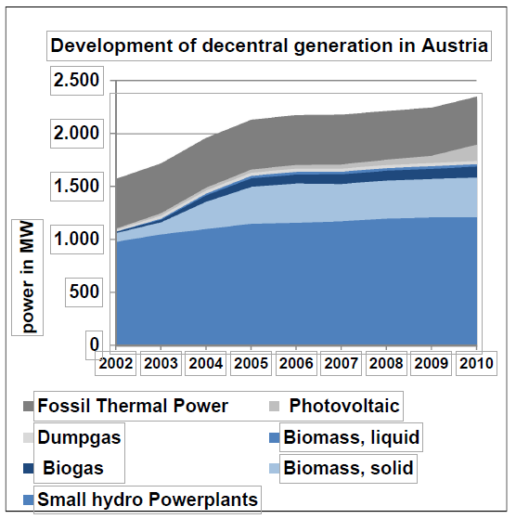
Figure 2 - Decentral electricity Production in Austria from 2002-2010, source: modified from E-Control - translated in English

The biggest part are small hydro powerplants, followed by solid biomass and fossil thermal power. Remarkable, that photovoltaic installations are increasing fast since 2008/2009. This trend can be described with the implementation of the amendment of the "Ökostromgesetz" in 2008, which promotes photovoltaic installations from 5kWp+. Large Wind parks are not considered in this figure.

Support mechanisms in Austria - the Ökostromgesetz:

The central support instrument in Austria for environmental-friendly produced electricity is the so called "Ökostromgesetz" (ÖSG) which provides law regulated compensation for electricity that is fed into the grid especially from small producers. These compensations are guaranteed for at least 13 or 15 years depending on the production, whether it is ressource-dependent (e.g. Biomass) or -independent (e.g. Photovoltaics). The grid feeding-compensations increased from 202 mln. euros in 2003 to 657 mln.euros in 2012. Beside the grid-feeding-compensations, there are investment incentives from the federal-states and the federal republic. The ÖSG exists since 2002 with important novels in 2006, 2009 and 2012.
Some improvements of the novel of 2012:
- 10 mio. € for the reduction of project waiting-lists including wind-, photovoltaic and small hydro power plants.
- Increasing the subsidies from 21 mln. euros to 50 mln. euros per year.
- New, binding development goals for the year 2020 (Table 4.2.)
- Subsidies for particular technologies
- Rearrangement of the support mechanism: more transparency in connection with siginificant reliefs for low-income households and energy-intensive coperations.

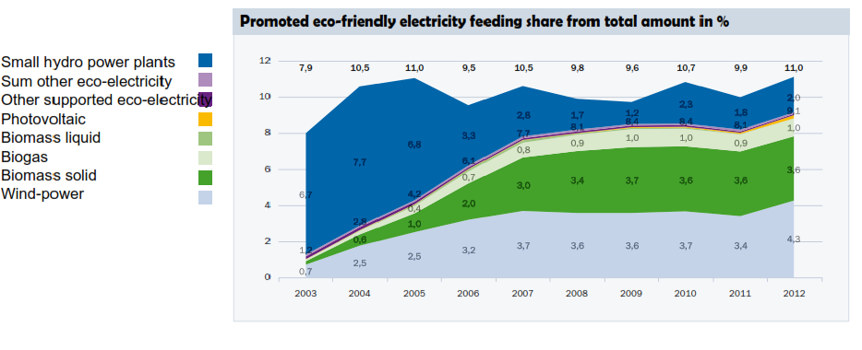
Figure 3 - Promoted share of electricty covered by the Ökostromgesetz, source: E-Control

As figure 3 shows, the amount of promoted produced power is quite stable since 2004. Only the different shares are varying. Wind power and especially solid biomass and biogas are increasing their shares, whereas the amount of subsidies for smaller hydro power plants is constantly decreasing. Hard to see in this figure, but the increase of photovoltaic was 157% from 2011 to 2012, the amount of facilities nearly doubled in one year. Altogether, there were 13512 contract-partners who received subsidies, generated through the Ökostromgesetz, whereas 11056 were photovoltaic-facilities. All in all 6152 GWh where fed in to the grid in 2012 from promoted facilities - mentionable: 2386 GWh wind, 1983 GWh solid biomass, 554 GWh biogas, 101 GWh photovoltaic (E-Control, 2013).

Developments goals in Austria:

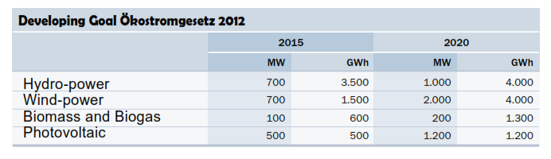
Table 1 - Developing Goals for promoted RES for 2015 and 2020 in Austria,
Source: E-Control

Wind power should nearly be tripled from 2015 to 2020, Biomass and Biogas subsidies should be doubled in this 5 years and Photovoltaic should be generate more than twice the amount of power in 2020 than it does in 2015. Only hydro-power, which was promoted in the past with absolutely the highest rates, should be promoted nearly at the same level, or only a slight increase.
Another goal from the ÖSG novel 2012 is the independency of nuclear power until 2015 and a share of 15% promoted production from the total electricity demand of Austria.
The EU´s energy target - to cover 20% of the whole energy consumption by RES - is a driver and will foster DG deployments.
"The potential for further increase of DG is sufficiently available, but deployment strongly depends on financial and political framework conditions. The Austrian energy strategy identified decentralized electricity and heat production as one major column to obtain the national energy targets. DG shall contribute to an increased energy efficiency as well as a growing amount of renewables. Implicitly DG shall strengthen the security of supply due to decreasing dependence on energy imports. Hence, the recently issued new version of the green energy law (Ökostromgesetz) provides improved incentives and rising numbers of new DG applications can be expected." Christine MATERAZZI-WAGNER, 2012.

4.2 Czech Republic

Czech central power system and current situation of DR:
The electricity system of the Czech Republic is based and operated on the same principles as the systems of others UCTE (Union for Coordination of Transmission of Electricity) member countries. The national transmission system operator (TSO) is ČEPS, which ČEPS has become participant in the cross-border trade mechanism since 1st January 2003.
The standardized voltage levels in Czech Republic are divided into three categories as follows: low voltage level - LV (up to 1000 V), high voltage level - HV (1 kV – 52 kV) and very high voltage level - VHV(over 52 kV).
The total installed capacity of power sources in CR is 20073 MV, the number of electricity generation license holders 13301 (ČEPS, official web-page).
The figure 4 shows the total generation profile of power system in CR. As one can notice, power plants in CR are by following types: Thermal Power Plant (TPP), Combined-Cycle Gas Turbine Power Plant (CCGT), Nuclear Power Plant (NPP), Hydro Power Plant (HPP), Pumped-Storage Plant (PsPP), Alternative Power Plant (AltPP), Autoproducer Power Plant (ApPP), Photovoltaic (PvPP) and Wind Power Plant (WPP).
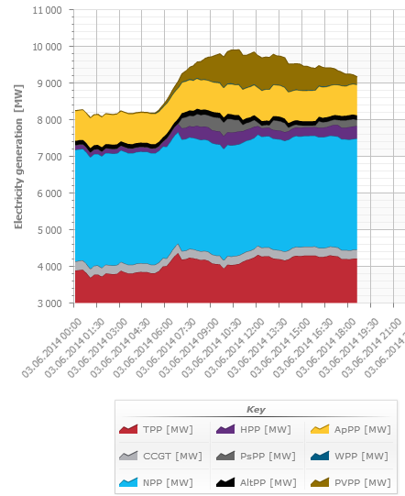

Figure 4 –Total gross electricity generation within the Czech power system according to individual power plant type (Source: ČEPS, official web-page, actual data: 03.06.2014)

The ČEPS transmission system is a part of the Czech power supply system, which links major entities operating within the power supply system and across which the majority of cross-border exchanges are carried out (R. Čížek, M. Malý - Review of technical options, 2003).
On the Fig 5 one can see the main component of central power grid in Czech Republic. It is seen that most of country’s territory is covered by central electrification.

Figure 5 - Map of the Czech transmission system (Source: ČEPS, official web-page)

The major aim of investment projects in power industry of ČR is to improve transmission of electricity generation by current generating facilities to the demand sites. Due to this fact, DG only plays a minimal role in meeting the demand of strengthening supply. Only in special cases, there is a role for DG in providing system services.
Distributed generation in the Czech Republic includes the following types of generating facilities:
- Coal-fired CHP plants operated by district heating companies with installed capacity up to 55 MWe per unit;
- Combined cycle gas turbine and gas-fired CHP plants operated by district heating companies;
- Small and medium-sized hydro power plants operated by district heating companies and also by distributed system operators (plants < 10 MW);
- Other RES sources.
The development of micro-grid projects during the last years in CR is shown on the Fig. 6.
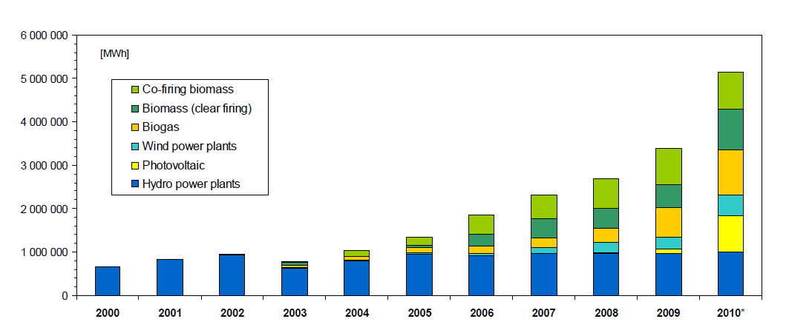
Figure 6 – Development of micro grids/RES during the last years

The review of supply from DG facilities connected directly to the distribution system in 2002 is presented in the following table. The share of DG in total net electricity generation was 32% (R. Čížek, M. Malý - Review of technical options, 2003). Taking into account the quick development of other microgrids during the last years we can assume that this figure is higher nowadays.

Table 2 - Electricity supply from DG facilities connected directly to the distribution system in 2002, in GWh

The most important RES for electricity generation are small hydro generating facilities. As far as the numbers of RES concerns, the majority of them are connected to the LV, but more important are the facilities connected to the HV. Their installed and production capacity exceeds the capacity of significantly higher number of facilities connected to the LV. In the Czech Republic as a small hydro generating facility is supposed such a facility which electricity generation output is up to 10 MW.
The majority of DG facilities are combined heat and power production units. The most important ones are connected to 110 kV level. The Energy Regulatory Office (ERO) collects statistical data about the electricity generating facilities from independent power producers. The other category are the so called auto-producers (i.e. generating facilities supplying mainly own legal entity and delivering less than 80% of yearly production to another market participant), which connect to the power system in high and very high levels (52-110 kV).

Technical barriers with regard to the planned development:
The rules for grid connection in the Czech Republic are standardized and publicly available. The basic rules are stipulated in the Energy Act, No 458/2000 Coll. and in the decree of the Ministry of Industry and Trade on conditions of interconnection and transport of electricity in electricity system, No. 18/2001 Coll.
These rules describe besides other issues the obligatory technical specification of electricity generating facilities for parallel operation with distribution facility, reactive power regulation, conditions for switching-on generators in public grid, possible influence on ripple control (widely used in ČR) etc.
The rules given in the Transmission Grid Code and Distribution Grid Code are issued and published by relevant operators upon the approval by ERO. The descriptions of particular conditions contained in codes are based on results of expertise and discussion, which is held by experts.
Standardized process for grid connections has already existed. The Energy Act and the Act on Energy Management stipulate some conditions for construction of new power plants. Construction of electricity generating plants with capacities of 30 MW and higher shall be allowed only upon state approval (‘authorization’). The Ministry for Industry and Trade is entitled to grant the authorization.

Existing support measures:
Most of mechanisms supporting DG in CR nowadays are the ones aimed to support RES development.
Main principles of renewable energy support are that the energy producers have priority access to the electricity grid and can choose between two types of support:
1. Fixed feed-in tariffs
- the buyer is a distribution or a transmission company
- 15 years payback period of investments is guaranteed
- price adjustments related to inflation
- Long term financial guarantees during the lifetime of RES for investors
2. Green bonuses
- the buyer is a trader or a customer
- distribution or transmission
- companies pay green bonuses to producers
- no long- term price guarantees
- higher risk for the producer but higher profit is possible
Legal Provisions:
Decree No. 475/2005 Coll., (revision in 2007, 2009 and 2010) sets procedures and timeframes for producers to choose between feed-in tariff and bonus (supporting scheme could be changed once per year) and contains the main typical technical and economical parameters as an input for price calculations:
- Specific investment costs of technologies per kW
- Utilization period at maximum capacity of the unit
- Typical lifetime of each technology
- Last revision of parameters in 2009 for all RES-new installations and in 2010 only for PV power plants
Decree No. 140/2009 Coll., about price regulation procedures: prices for RES-E are adjusted annually according to inflation from 2% up to 4% (excluding biogas and biomass); support is guaranteed for the typical lifetime of each technology.
As a result of supporting measures in CR, the total installed capacity of such renewables as photovoltaic plants has strongly increased. This is the result of adjusted feed-in tariff. Other technologies (biomass, biogas, wind power plants) have also increased their shares during last years.
As conclusion one can say that distributed generation in Czech Republic is mainly connected to the distribution network, at voltages lower than 120/110 kV, depending on the DG size. So far DG has quite a low share in power production and is therefore not influencing network quality. The benefits of some DG sources are not yet fully recognized but could be significant in some areas with weak networks.
There is no high specific technical constraints to DG have been found. The existing DG sources are mainly hydropower and CHP plants. The supporting schemes initiated for the last years should help significantly develop the field of distributed generation in CR.

6. CONCLUSIONS
Distributed generation is an alternative way to generate power. DG sources can be connected to the common power-grid or an autonomous grid. In last case this happens in small local stand-alone power plants mostly from renewable sources.
Main benefits of DG is that it can be used as back-up or main power source for the need of decentralized customers, it can also defer investment in the transmission and distribution network, reduce line losses, defer the construction of large generation facilities, displace more expensive grid-supplied power, provide additional sources of supply in markets and provide environmental benefits.
The main problem is nowadays that it cannot provide such low economies of scales like huge central power plants. Other barriers are the ones related to the power quality of electricity in power grid.
But as soon as the oil, gas or coal prices are rising, central power plants will become obsolete more and more. Also if we decide to pursue a more environmental friendly energy policy, which happens e.g. in the European Union already, we have to focus more on small, decentralized generation from renewable resources and then DG becomes a keyword.
Both Czech Republic and Austria are members of UCTE so that they are participants of common European electricity market. The voltage levels division differs a bit however both countries in most cases use distribution voltage level for connection of DG. Comparison of situations in CR and Austria has shown that in both countries DG is mainly connected to the common power-grid. Both countries offer subsidies, regulated by law for power generation systems which use RES. One of the main differences is, that DG has a share of 32% from total net electricity production in the CR and only 16% in Austria. The amount of DG from RES is about 5 TWh in the CR and nearly 9 TWh in Austria. So the CR has a much higher share of fossil energy in DG. Both countries show an increasing share of RES in DG. Austria has the advantage, due to the topological situation, that more small hydro-power-plants could be constructed, which covers a high share of the DG. Since 2003 power plants using biomass and wind-power-plants are establishing and they have potential for the future.

7. REFERENCES
[1]Towards a future with large penetration of distributed generation: Is the current regulation of electricity distribution ready? Regulatory recommendations under a European perspective - Rafael Cossent, Toma´s Go´mez, Pablo Frı´as, Instituto de Investigacio´n Tecnolo´gica, Escuela Te´cnica Superior de Ingenierı´a, Universidad Pontiﬁcia Comillas, C/ Quintana 21, 28008 Madrid, Spain
[2] Distributed generation technologies and optimization - Lucian Ioan Dulăua,*, Mihail Abrudeanb, Dorin Bicăc, The 7th International Conference Interdisciplinarity in Engineering,2013
[3] ADRES – Autonome Dezentrale Regenerative Energie Systeme, DI Alfred EINFALT et al., 2008, 10. Symposium Energieinnovation Graz
[4] DISTRIBUTED GENERATION IN AUSTRIA, Christine MATERAZZI-WAGNER, 2012, CIRED Workshop Lisbon
[5] GROW-DERS: Grid reliability and operability with distributed generation using flexbible stroage, Petra de Boer et al., 2010, CIRED Workshop Lyon
[6] Impact of Distributed Generation on Power Distribution Systems, K. Balamurugan, Dipti Srinivasan, Thomas Reindl, PV Asia Pacific Conference, 2011
[7] National Renewable Energy Laboratory, web-site: http://www.nrel.gov/learning/eds_distributed_energy.html
[8] Review of the Distributed Generation Concept: Attempt of Unificatio, F. Gonzalez-Longatt1, C. Fortoul.
[9] Policy and Regulatory Roadmaps for the Integration of Distributed Generation and the Development of Sustainable Electricity Networks, R. Čížek, M. Malý - Review of technical options and constraints for integration of distributed generation in electricity networks, SUSTELNET project
[10] Distributed Generation: Definition, Benefits and Issues, Pepermans G., Driesen J., Haeseldonckx D., D’haeseleer W., Belmans R., K.U.Leuven - Energy Institute, 2003
[11] E-Control, Regulative authority in Austria, Ökobericht 2013
[12] The national transmission system operator in Czech Republic ČEPS, official web-page: http://www.ceps.cz/
[13] E-Control, Regulative authority in Austria, Dezentrale Erzeugung in Österreich, 2012
[14] E.Mgaya , Z.Muller – Impact of Connecting Distributed Generation to the Distribution System, Acta polytechnica vol.47, 2007.

